­

COMPUTER

|  |  |
| --- | --- |
| Name | Saikat Saha |
| Class | XII Science |
| Roll |  |

2020-21

SCHOOL MANAGEMENT SYSTEM

PROJECT FILE

SUBMITTED BY:

PYTHON

*The joy of coding Python should be in seeing short, concise, readable classes that express a lot of action in a small amount of clear code – not in reams of trivial code that bores the reader to death.*

-Guido Van Rossum

**CERTIFICATE**

This is to certify that **Saikat Saha** has successfully completed the project Work entitled **SCHOOL MANAGEMENT SYSTEM** in the subject Computer Science (083) laid down in the regulations of CBSE for the purpose of Practical Examination in Class XII session 2020-2021

Teacher Principal Examiner

(sign.) (sign.) (sign.)

**INDEX**

|  |  |  |
| --- | --- | --- |
| S.No. | Description | Page No |
| 1 | Acknowledgement | 4 |
| 2 | Introduction | 5 |
| 3 | Objective of the Project | 5 |
| 4 | Source Code | 6-14 |
| 5 | Output Code | 15-17 |
| 6 | Hardware and Software Requirements | 18 |
| 7 | Bibliography | 19 |

**ACKNOWLEDGEMENT**

Apart from the efforts of me, the success of any project depends largely on the encouragement and guidelines of many others. I take this opportunity to express my gratitude to the people who have been instrumental in the successful completion of this project.

I express deep sense of gratitude to almighty God for giving me strength for the successful completion of the project.

I express my heartfelt gratitude to my parents for constant encouragement while carrying out this project.

I gratefully acknowledge the contribution of the individuals who contributed in bringing this project up to this level, who continues to look after me despite my flaws.

I express my deep sense of gratitude to the luminary The Principal, D.A.V Public School, E.C.L, Pandaveswar, who has been continuously motivating and extending their helping hand to us.

I express my sincere thanks to the academician The Vice Principal, D.A.V Public School, E.C.L, Pandaveswar, for constant encouragement and the guidance provided during this project

I am overwhelmed to express my thanks to The Administrative Officer for providing me an infrastructure and moral support while carrying out this project in the school.

My sincere thanks to **Mr. Sanjiv Kumar Roy**, Teacher, A guide, Mentor all the above a friend, who critically reviewed my project and helped in solving each and every problem, occurred during implementation of the project

Saikat Saha,

Class XII Science

Board Roll No:

**INTRODUCTION**

This project is based on management of School, such as informations about the students such as his/her marks, etc. These information can be stored in the databases and can be verified whenever we want this. Computer programme can be used for schools etc..

­­­

**OBJECTIVES OF THE PROJECT**

The objective of this project is to let the students apply the programming knowledge into a real- world situation/problem and exposed the students how programming skills helps in developing a good software.

1. Write programs utilizing modern software tools.
2. Write effective procedural code to solve small to medium sized problems.
3. Students will demonstrate a breadth of knowledge in computer science, as exemplified in the areas of systems, theory and software development.

Students will demonstrate ability to conduct a research or applied Computer Science project, requiring writing and presentation skills which exemplify scholarly style in computer science

**SOURCE CODE**

import mysql.connector

import pickle, os

import prettytable as pt

from matplotlib import pyplot as plt

setupcommand = ['create database school;',

'use school;',

'create table student('

'adm_no int(6) not null primary key,'

'name varchar(30) not null,'

'class int(2) not null,'

'Section varchar(30) not null,'

'attendance int(3) not null,'

'english int(3) not null,'

'bengali_or_hindi int(3) not null,'

'science int(3) not null,'

'social_science int(3) not null,'

'maths int(3) not null);']

def restart():

global status

c = input('You Want to do more (Return To HomeScreen) : (\'y\'/\'n\')')

if c != 'y' and c != 'Y':

print('Have a Good Day !!!!')

status = 'stopped'

def varcharfix(f, r):

if f == 'name' or f == 'section':

r = f'\'{r}\''

return r

def setup():

global c

host = str(input('Enter the Host (DataBase) = '))

user = str(input('Enter the User (DataBase) = '))

password = str(input('Enter the Password (DataBase) = '))

con = mysql.connector.connect(host=host, user=user, password=password)

print('It\'s time you setup a username and password !!!')

u = str(input('Enter your Username : '))

p = str(input('Enter your Password : '))

with open('data.dat', 'wb+') as fw:

pickle.dump([host, user, password, u, p], fw)

c = con.cursor()

for cmd in setupcommand:

c.execute(cmd)

print('Installation completed !, now wait for the program to run !!!!!')

def startup():

while True:

try:

if 'data.dat' not in os.listdir():

setup()

else:

try:

with open('data.dat', 'rb+') as fr:

a = pickle.load(fr)

host, user, password = a[0], a[1], a[2]

con = mysql.connector.connect(host=host, user=user, password=password, db='school')

c = con.cursor()

if len(a) != 5:

setup()

break

except:

setup()

except mysql.connector.errors.InterfaceError:

print('Your host that is mentioned, is not there make sure to check it next time !!!!')

except mysql.connector.errors.ProgrammingError:

print('Make sure to enter the correct username and password, next time !!!!')

except mysql.connector.errors.DatabaseError:

try:

with open('data.dat', 'rb+') as fr:

a = pickle.load(fr)

host, user, password = a[0], a[1], a[2]

con = mysql.connector.connect(host=host, user=user, password=password, db='school')

c = con.cursor()

for cmd in setupcommand:

if setupcommand.index(cmd) != 0:

c.execute(cmd)

print('Installation completed !, now wait for the program to run !!!!!')

break

except mysql.connector.errors.ProgrammingError:

print('Installation completed !, now wait for the program to run !!!!!')

break

startup()

with open('data.dat', 'rb+') as fr:

a = pickle.load(fr)

host, user, password = a[0], a[1], a[2]

con = mysql.connector.connect(host=host, user=user, password=password, db='school')

c = con.cursor()

ofn = ['adm_no', 'name', 'class', 'section', 'attendance', 'english', 'bengali_or_hindi', 'science', 'social_science',

'maths']

tri = 0

status = 'running'

while status == 'running':

try:

print('You are a : \n'

'1. Teacher \n'

'2. Student')

attempt = 0

c1 = int(input('Enter the number of Choice : '))

if c1 == 1:

trial = 'notended'

while trial != 'ended':

print('It\'s time, you verify your authorization !!!!!')

u = str(input('Enter your Username : '))

p = str(input('Enter your Password : '))

if u == a[3] and p == a[4]:

trial = 'ended'

print('Welcome Back, you are provided your permissions below !!!!')

print('1. View details'

'\n2. Add entries'

'\n3. Modify entries'

'\n4. delete entries'

'\n5. reset')

c2 = int(input('Enter your Choice : '))

if c2 == 1:

alil = []

sout = ''

fout = ''

aout = ''

print('Select from below which columns you want to see :\n'

'adm_no, name, class, section, attendance, english, bengali_or_hindi, science, '

'social_science, maths, *(for all columns)')

colsel = str(input('Please select columns mentioned above separated with \',\' : '))

sort = str(input('Sorting needed ? (y/n) : '))

filters = str(input('Filtering needed ? (y/n) : '))

alias = str(input('Aliasing Required(calculating existing column) ? (y/n) : '))

if sort == 'y' or sort == 'Y':

sortt = str(input('Sorting type ? ( \n a for ascending\n d for descending)'))

s = str(

input('Enter the Column mentioned above according to which needs to be sorted : '))

if sortt == 'a':

sout = f' order by {s}'

if sortt == 'd':

sout = f' order by {s} desc'

if filters == 'y' or filters == 'Y':

nfilter = int(input('How many filters required (\'not more than 2\') ? : '))

for i in range(nfilter):

f = str(input('Enter the column with which to be filtered : '))

o = str(input('Enter the operator from mentioned one (=, <, >, <=, >=, !=) :'))

r = str(input('Enter the value : '))

r = varcharfix(f, r)

ifout = f + o + r

if fout == '':

fout = f' where {ifout} '

else:

fout += f'and {ifout}'

if alias == 'y' or alias == 'Y':

nal = int(input('Enter the number of alias : '))

for i in range(nal):

al = str(input('Enter the alias name : '))

fo = str(input('Enter the value of alias with respect to columns mentioned : '))

iaout = f',{fo} as {al}'

aout += iaout

alil.append(al)

cmd = f'select {colsel}{aout} from student{fout}{sout};'

try:

c.execute(cmd)

v = c.fetchall()

norcol = colsel.split(',')

if '*' in norcol:

norcol.remove('*')

norcol = ['adm_no', ' name', 'class', 'section', 'attendance', 'english',

'bengali_or_hindi',

'science',

'social_science', 'maths']

fieldname = norcol + alil

vtab = pt.PrettyTable()

vtab.field_names = fieldname

for i in v:

vtab.add_row(i)

print(vtab)

except mysql.connector.errors.ProgrammingError:

print('Please be precise on entry of data !!!!!!!')

elif c2 == 2:

c2c = 'y'

while c2c == 'y' or c2c == 'Y':

print('Please fill the below mentioned => ')

adm = int(input('Admission Number = '))

name = str(input('Name = '))

clas = int(input('Class (in Number) = '))

sec = str(input('Section = '))

att = int(input('Attendance (in %) = '))

eng = int(input('English (in %) = '))

beng = int(input('Bengali/Hindi (in %) = '))

sc = int(input('Science (in %) = '))

sst = int(input('Social Science (in %) = '))

math = int(input('Mathematics (in %) = '))

c.execute(f'insert into student values(' f'{adm},\'{name}\',{clas},\'{sec}\',{att},{eng},{beng},{sc},{sst},{math});')

con.commit()

print('Data Entered !!!!')

c2c = input('Want to enter more data (y/n) : ')

elif c2 == 3:

mout = ''

md = {}

print('first let\'s see, which rows you need to modify ....')

fout = ''

nfilter = int(input('How many conditions required (\'not more than 2\') ? : '))

for i in range(nfilter):

f = str(input('Enter the column with which to be identified : '))

o = str(input('Enter the operator from mentioned one (=, <, >, <=, >=, !=) :'))

r = str(input('Enter the value : '))

r = varcharfix(f, r)

ifout = f + o + r

if fout == '':

fout = f'{ifout}'

else:

fout += f'and {ifout}'

print('Please fill the required ones from below mentioned and skip other ones => ')

adm = str(input('Admission Number = '))

name = str(input('Name = '))

clas = str(input('Class (in Number) = '))

sec = str(input('Section = '))

att = str(input('Attendance (in %) = '))

eng = str(input('English (in %) = '))

beng = str(input('Bengali/Hindi (in %) = '))

sc = str(input('Science (in %) = '))

sst = str(input('Social Science (in %) = '))

math = str(input('Mathematics (in %) = '))

mr = [adm, name, clas, sec, att, eng, beng, sc, sst, math]

for i in ofn:

for t in mr:

if t != '' and (i != 'name' and i != 'section'):

md[i] = t

elif t != '' and (i=='name' or i=='section'):

tn = f'\'{t}\''

md[i] = tn

mr.remove(t)

break

for i in list(md.keys()):

if mout == '':

mout = f'{i}={md[i]}'

else:

mout += f',{i}={md[i]}'

cmd = f'update student set {mout} where {fout};'

c.execute(cmd)

con.commit()

print('Data Modified Successfully !!!!!')

elif c2 == 4:

print('first let\'s see, which rows you need to delete ....')

fout = ''

nfilter = int(input('How many conditions required (\'not more than 2\') ? : '))

for i in range(nfilter):

f = str(input('Enter the column with which to be deleted : '))

o = str(input('Enter the operator from mentioned one (=, <, >, <=, >=, !=) :'))

r = str(input('Enter the value : '))

r = varcharfix(f, r)

ifout = f'{f}{o}{r}'

if fout == '':

fout = f'{ifout}'

else:

fout += f'and {ifout}'

cmd = f'delete from student where {fout};'

c.execute(cmd)

con.commit()

print('The Row you selected is successfully deleted!!!!!')

elif c2 == 5:

while True:

print('Please re-enter the username and password to proceed !!!')

u = str(input('Enter your Username : '))

p = str(input('Enter your Password : '))

if u == a[3] and p == a[4]:

c.execute('truncate table student;')

print('Your database is cleaned !!!!!!')

break

if tri == 5:

print('As I suspected, you are an intruder !!!!!')

break

else:

tri += 1

print(f'Wrong Username and Password !!!!!, Retrying.... {5 - tri} left ....')

else:

print(f'Not able to find Your choice({c2}) !!!!!!!! ')

elif attempt == 4:

print('\'Limits Crossed !!!!,UNAUTHORIZED ACCESS DETECTED !!!!!!, SERVERS CLOSING DOWN!!!!')

break

else:

attempt += 1

print(f'Wrong Username and Password !!!!!, Retrying.... {5 - attempt} left ....')

elif c1 == 2:

adm_no = int(input('Enter your Admission Number : '))

c.execute(f'select * from student where adm_no={adm_no};')

a = c.fetchone()

if a is None:

print(f'You are not registered , admission number = {adm_no}')

else:

print(' Your Details '

f'\nAdmission Number = {a[0]}'

f'\nName = {a[1]}'

f'\nClass (in Number) = {a[2]}'

f'\nSection = {a[3]}'

f'\nAttendance (in %) = {a[4]}'

f'\nEnglish (in %) = {a[5]}'

f'\nBengali/Hindi (in %) = {a[6]}'

f'\nScience (in %) = {a[7]}'

f'\nSocial Science (in %) = {a[8]}'

f'\nMathematics (in %) = {a[9]}')

p = plt.bar(['Attendance', 'English', 'Bengali/Hindi', 'Science', 'Social Science', 'Mathematics'], [i for i in a[4:]])

plt.show()

else:

print(f'Not able to find Your choice({c1}) !!!!!!!! ')

except ValueError:

print('Aren\'t you are being illogical, please enter the data according to field names !!!!')

except SyntaxError:

print('First install through setup, then try this !!!!!!!!')

except EOFError:

print('Delete all files (data.dat) except program ones from this folder, it is causing hindrances !!!!')

except mysql.connector.ProgrammingError and mysql.connector.DatabaseError:

print('Due to some manipulations, our connections are failing, so try uninstalling and reinstalling !!!!!')

finally:

restart()

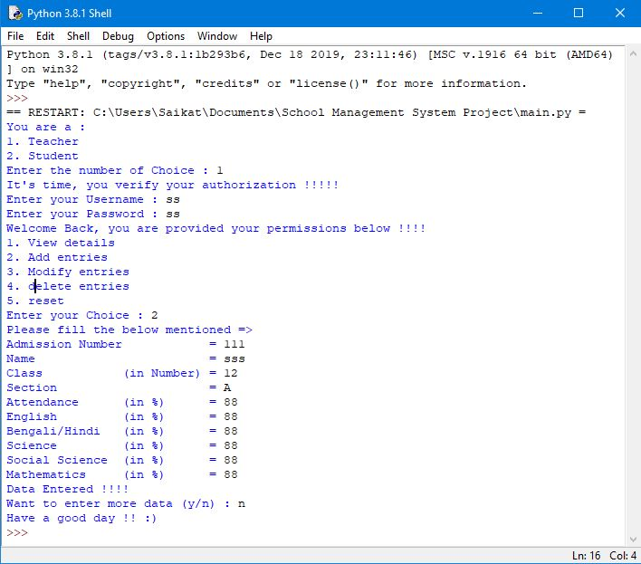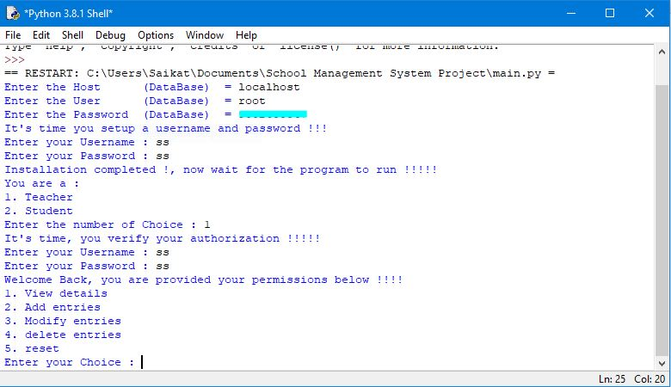**OUTPUT**

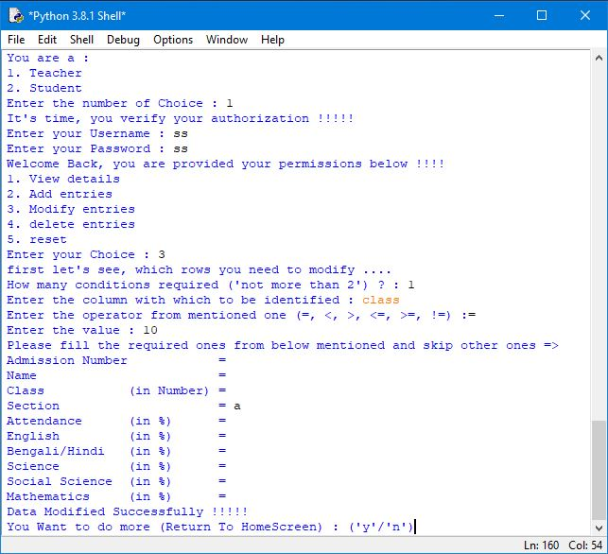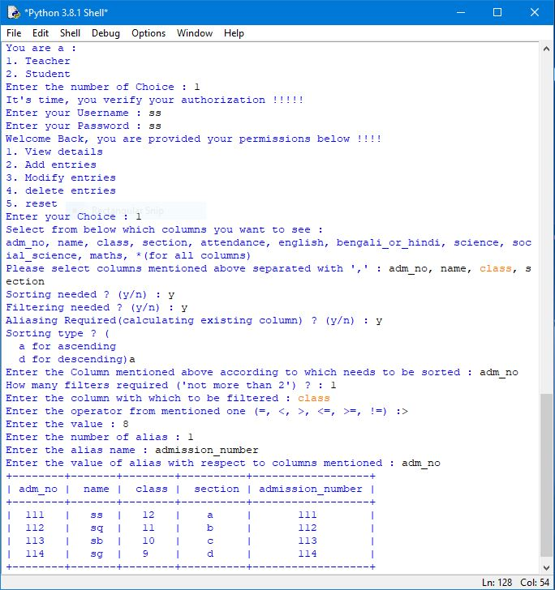

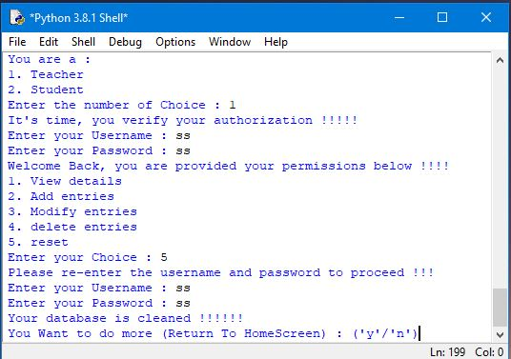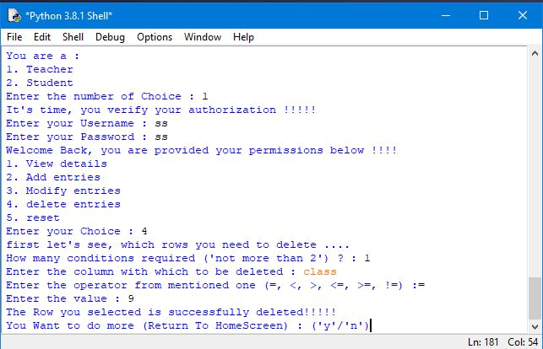

**Hardware and Software Requirements**

**HARDWARE REQUIREMENTS:**

I.OPERATING SYSTEM : WINDOWS 7 AND ABOVE

II. PROCESSOR : PENTIUM(ANY) OR

AMD ATHALON(3800+- 4200+ DUALCORE)

III. MOTHERBOARD : 1.845 OR 915,995 FOR PENTIUM

0R MSI

K9MM-V VIAK8M800+8237R

PLUS FOR AMD ATHALON

IV. RAM : 512MB+

V. Hard disk : SATA 40 GB OR ABOVE

VI. CD/DVD r/w multi drive combo : (If back up required)

VII. FLOPPY DRIVE 1.44 MB : (If Backup required)

VIII. MONITOR 14.1 or 15 -17 inch

IX. Key board and mouse

**SOFTWARE REQUIREMENTS:**

1. Windows OS
2. Python( **MODULES REQUIRED** : mysql.connector, pickle, os, sys, prettytable )

**BIBLIOGRAPHY**

1. Computer Science With Python : By Preeti Arora
2. Website: <https://www.geeksforgeeks.org/>
3. Youtube Channel followed:

<https://www.youtube.com/channel/UC4JX40jDee_tINbkjycV4Sg>

1. Sample Projects :

<https://github.com/github>

1. IDE used:

PyCharm, Sublime Text, Spyder